**JUNIPER-CISCO REDISTRIBUTION LAB**

**Network Topology:**

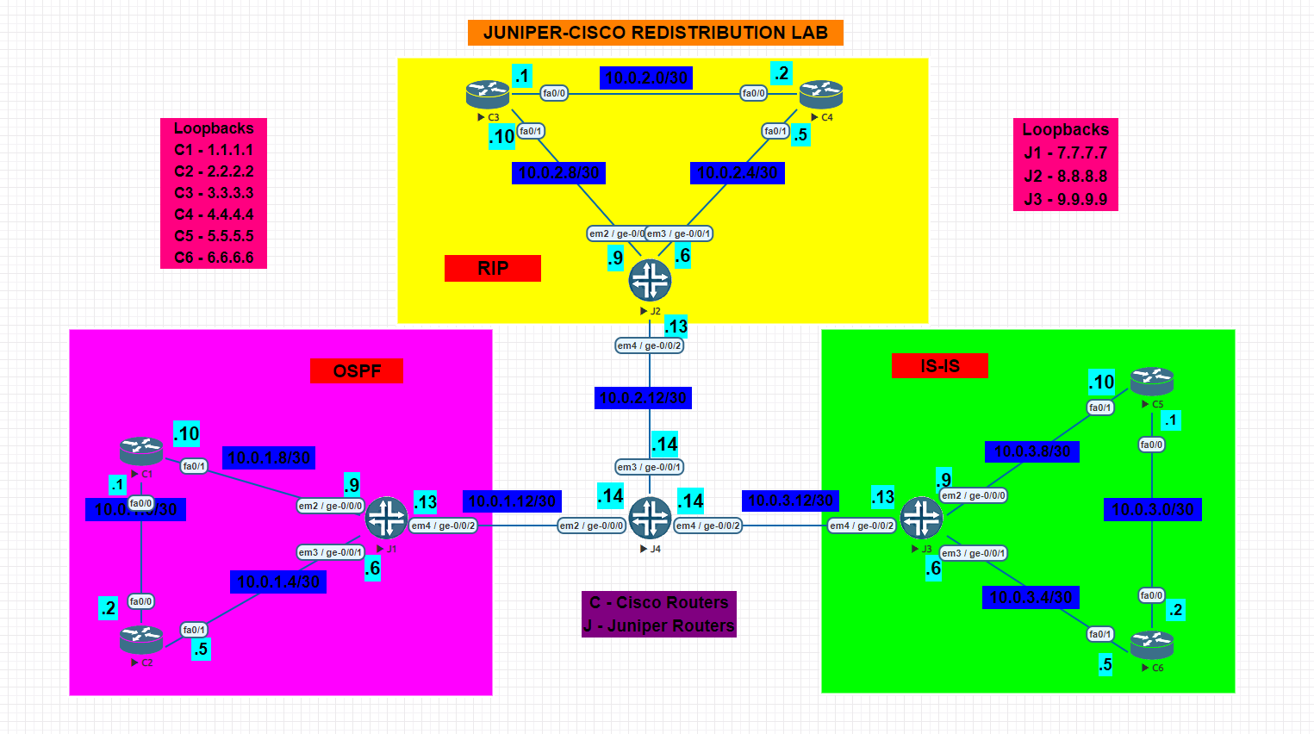

**NOTE: Perform all the basic configuration on Juniper Router given in Juniper Static Routing Lab before performing the lab**

**NOTE: Perform all the basic configuration on Juniper Router before performing the lab**

* **In the above given topology, C2 and J2 routers belong to Area 0.**
* **C1, C2 and J1 are running OSPF in Area 0.**
* **J2, C3, C4 are running RIP version 2.**
* **J3, C5, C6 are running IS-IS Level 2.**
* **J4 (Redistribution done here) interfaces according to the topology**
* **All the 6 loopbacks are configured as below:**
  + **C1: 1.1.1.1**
  + **C2: 2.2.2.2**
  + **C3: 3.3.3.3**
  + **C4: 4.4.4.4**
  + **C5: 5.5.5.5**
  + **C6: 6.6.6.6**

1. **Configure the respective physical interfaces & also configure the loopback interfaces on all the routers in the configuration mode as per the network topology:**

**CISCO Routers:**

**C1:**

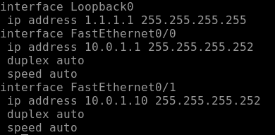

**C2:**

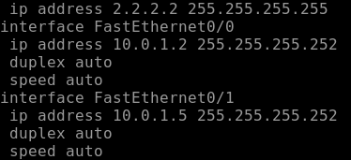

**JUNIPER Routers:**

**J1:**

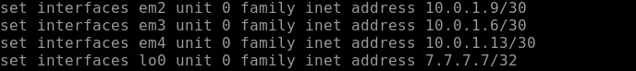

**J4:**

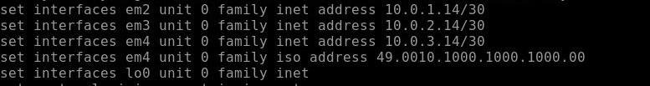

1. **Verify using the show command that all the interfaces are configured correctly.**

**CISCO Routers:**

**C1:**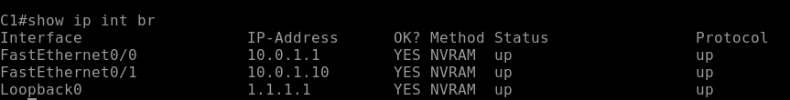

**C2:**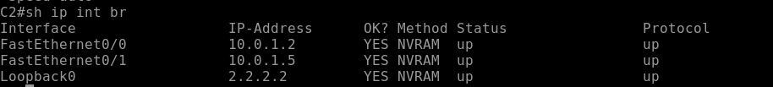

**JUNIPER Routers:**

**J1:**  
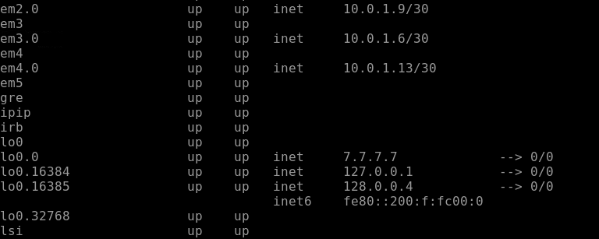

**J4:**  
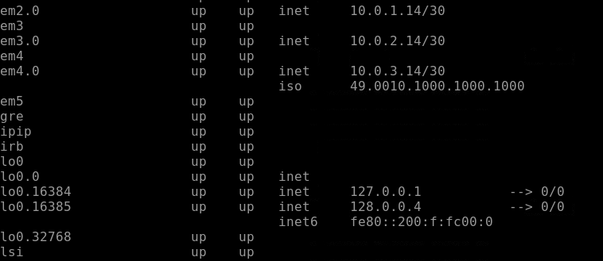

1. **Configure OSPF on C1, C2 , J1 Routers & advertise loopback 0 as Router ID in Area 0.**

**C1:**

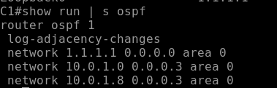

**C2:**

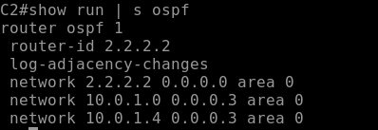

**J1:**

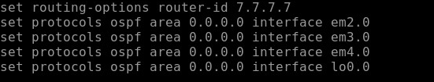

**J4:**



1. **Run RIPv2 protocol on C3, C4, J2 Routers & advertise their respective network. For J2 Create a Routing policy such that it advertises both the direct & RIP learned routes. Also set import & export rules for the routes learnt from RIP**

**C3:**

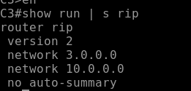

**C4:**

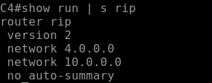

**J2:**

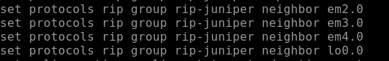





**J4:**





1. **Configure IS-IS on C5, C6, J3 Routers as per the topology and configure the interfaces in ISO family and configure the CLNS address for loopback interface. Set Level-2 on these routers and enable IS-IS in interfaces. For J3 Configure Policy statements on IS-IS router for accepting and sending routes to the routers.**

**C5:**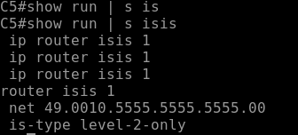

**C6:**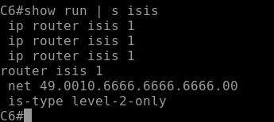

**J3:**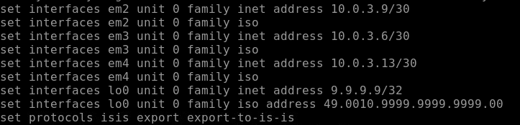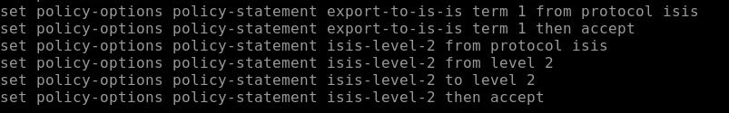

**J4:**

1. **Advertising and redistributing and applying policy statements on J4 router for OSPF, IS-IS and RIP.**

**J4:**

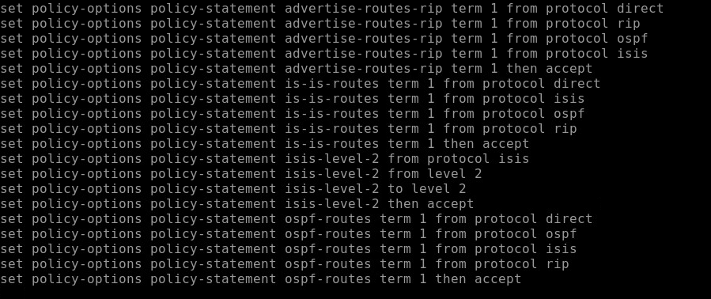

1. **Verify OSPF neighborship**

**C1:**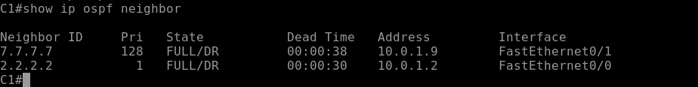

**C2:**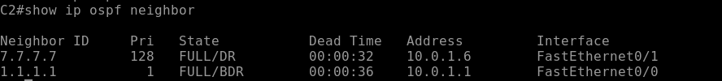

**J1:**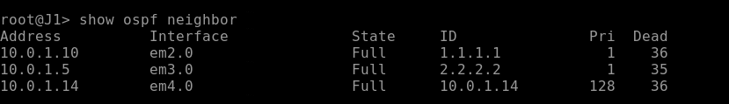

1. **Verify IS-IS neighborship**

**C5:**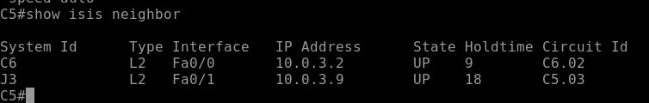

**C6:**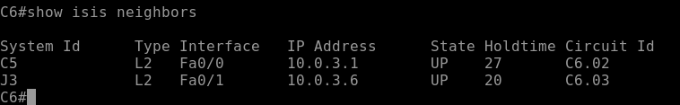

**J3:**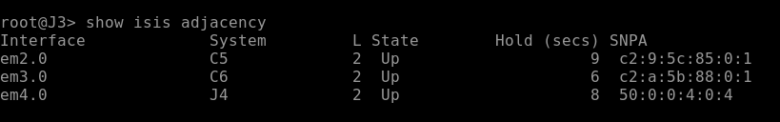

1. **VERIFY ROUTING TABLE FOR ALL ROUTERS**

**C1:**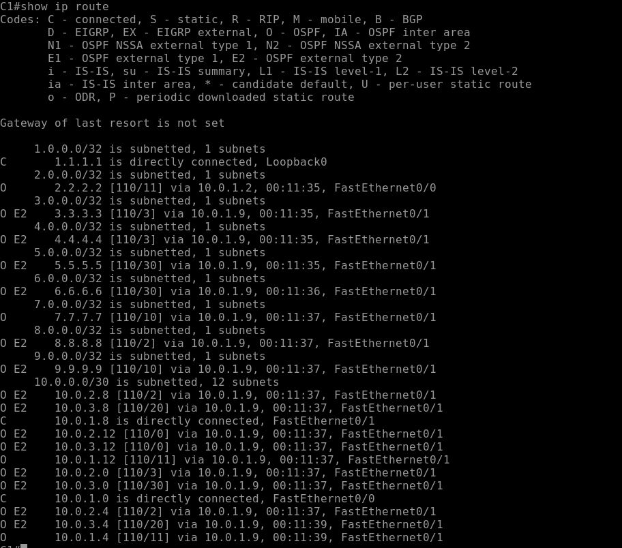

**J1:**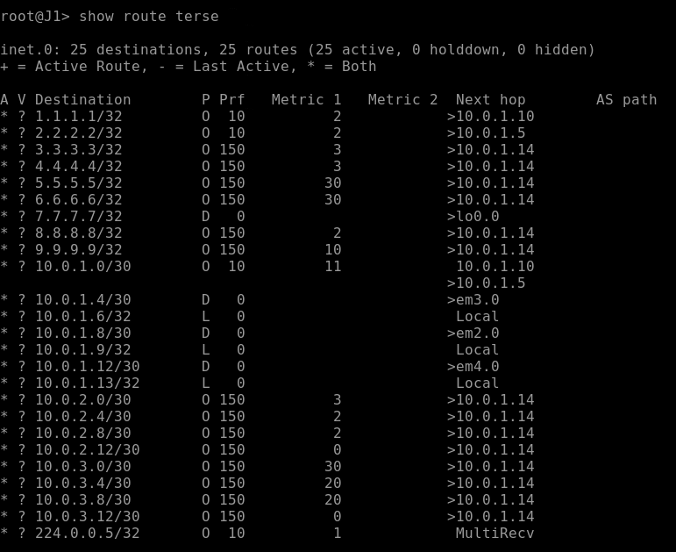

**C3:**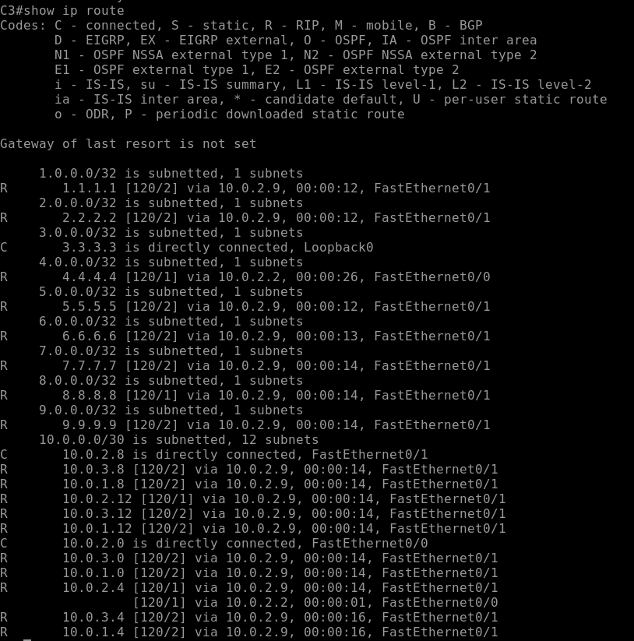

**J2:**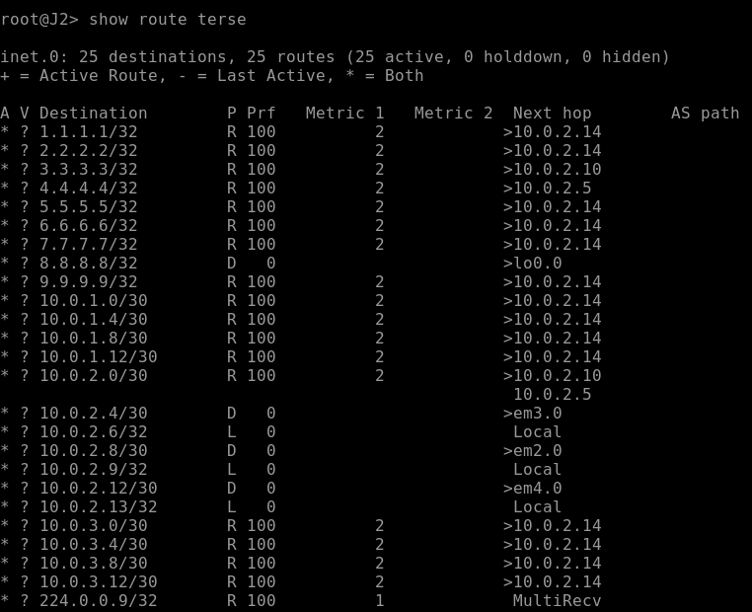

**C5:**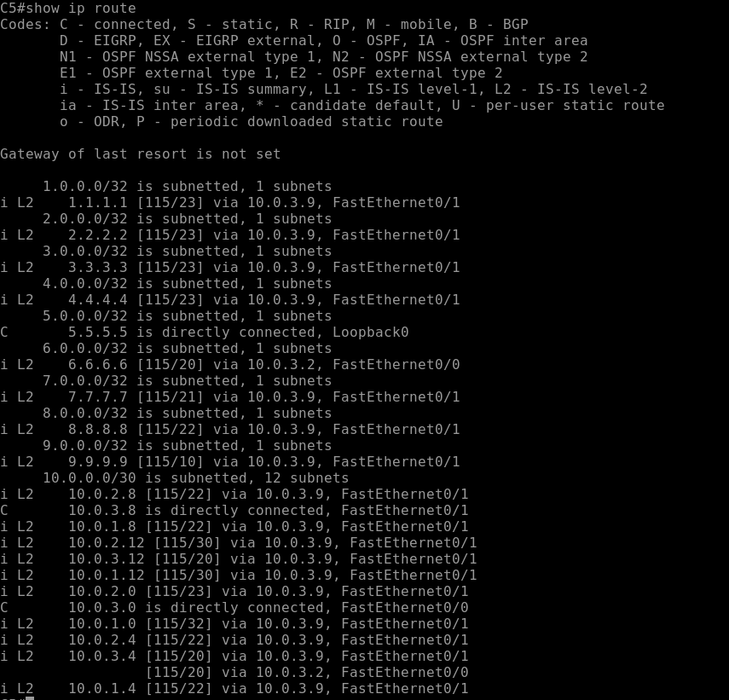

**J3:**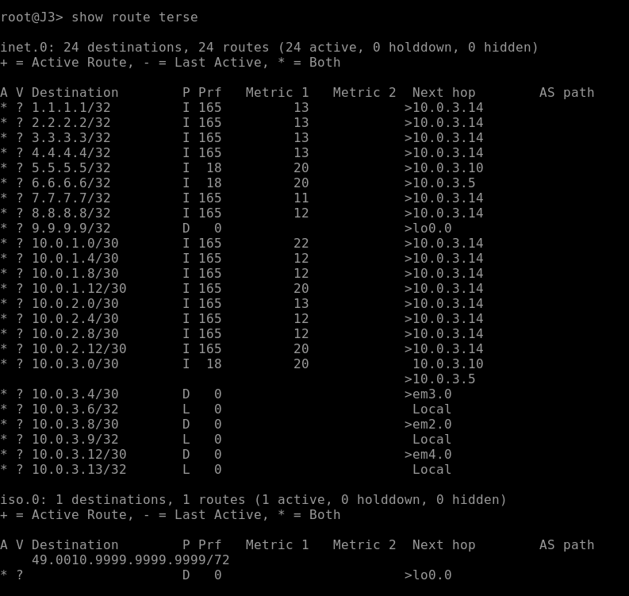

**J4:**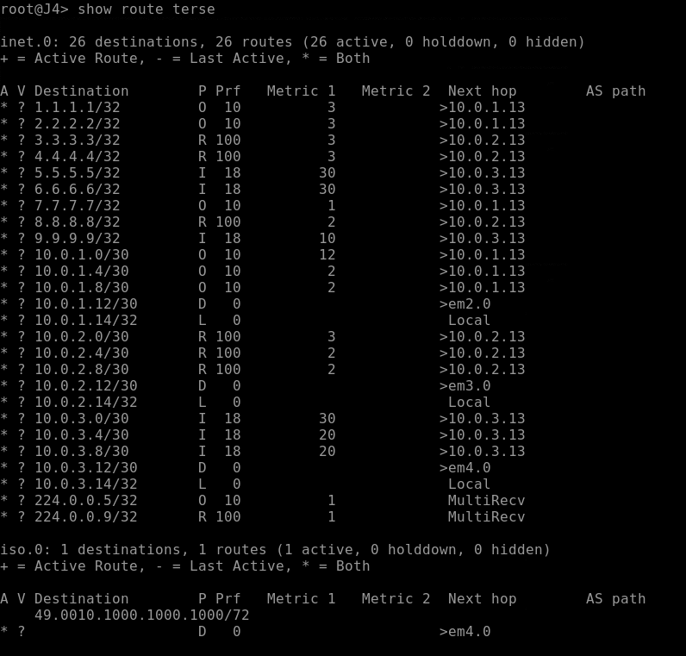

1. **Verify the end to end connectivity using Ping.**

**C1 to C3:**

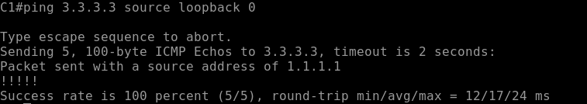

**C1 to C5:**

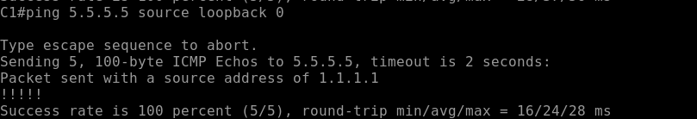

**C2 to C4:**

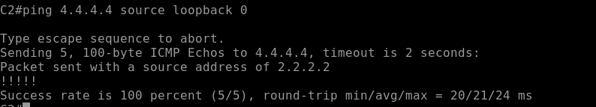

**C2 to C6:**

